AWS Task – 4

EC2: 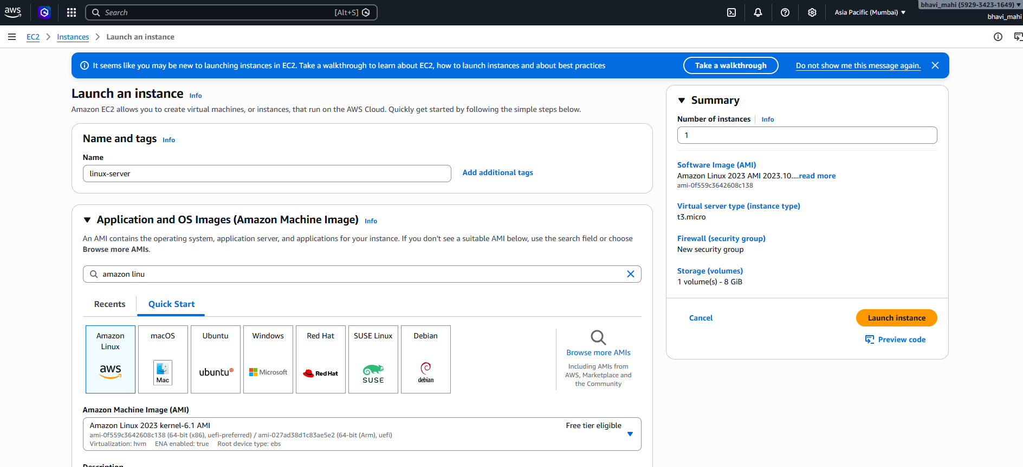

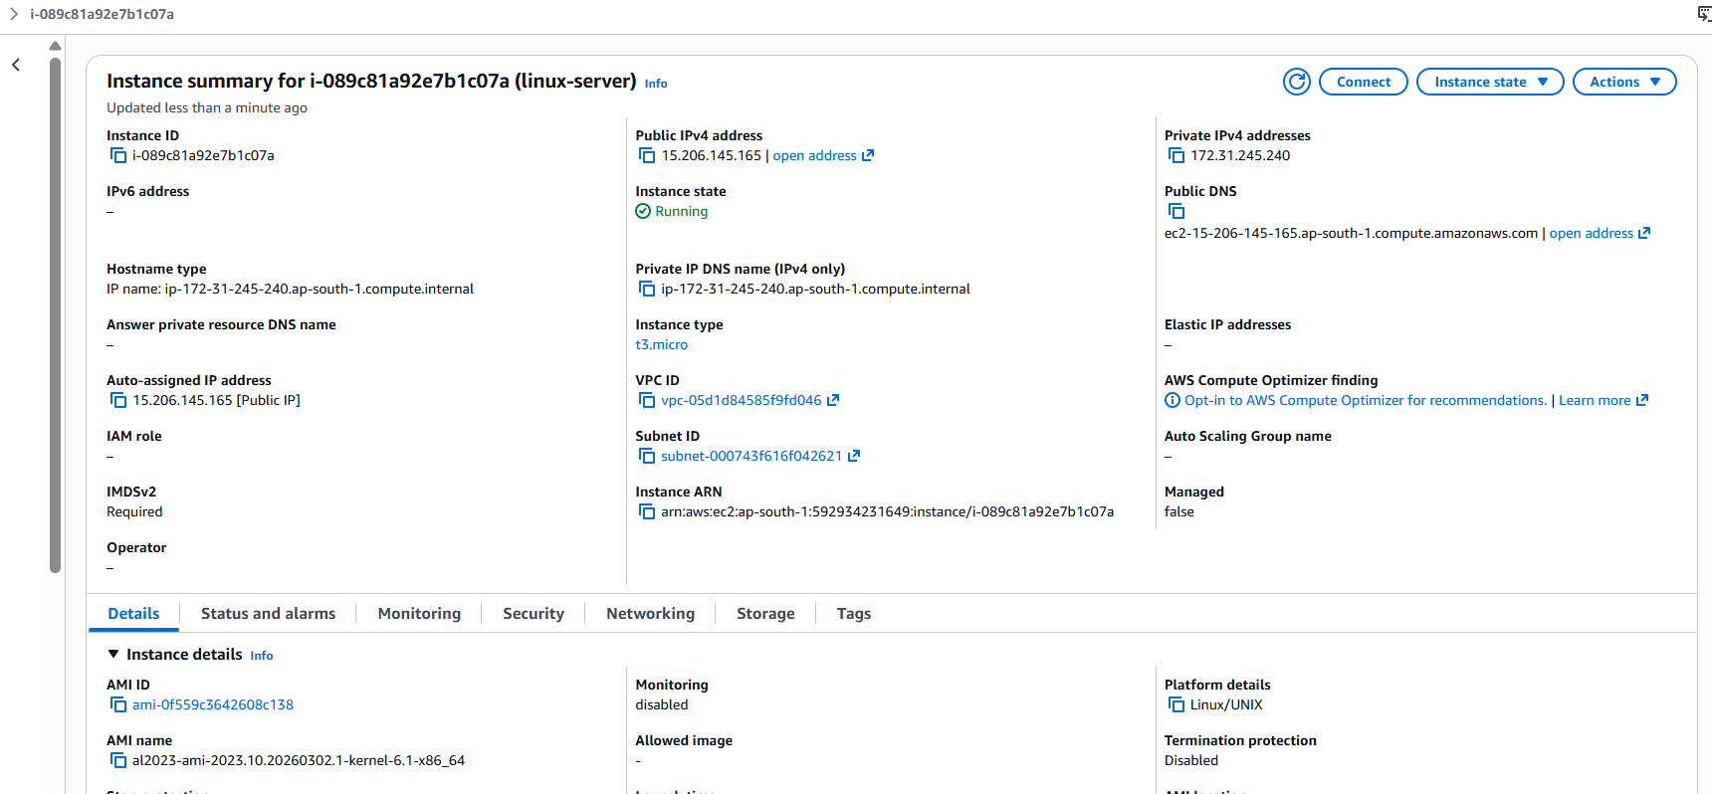

Install Web Server:

ssh -i key.pem ec2-user@public-ip

sudo yum update -y
sudo yum install httpd -y
sudo systemctl start httpd
sudo systemctl enable httpd

echo "Hello from Linux Server" | sudo tee /var/www/html/index.html

Windows server EC2:

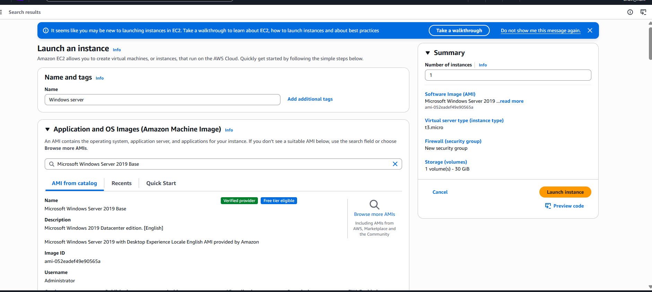

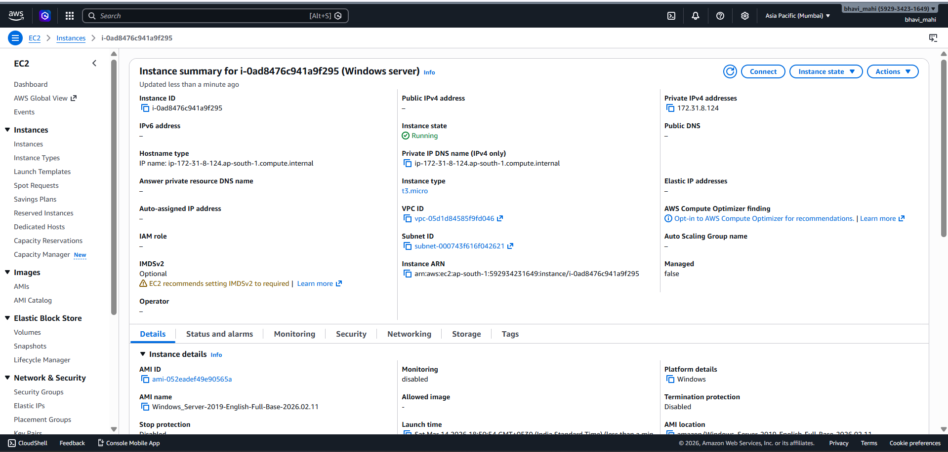

RDP:

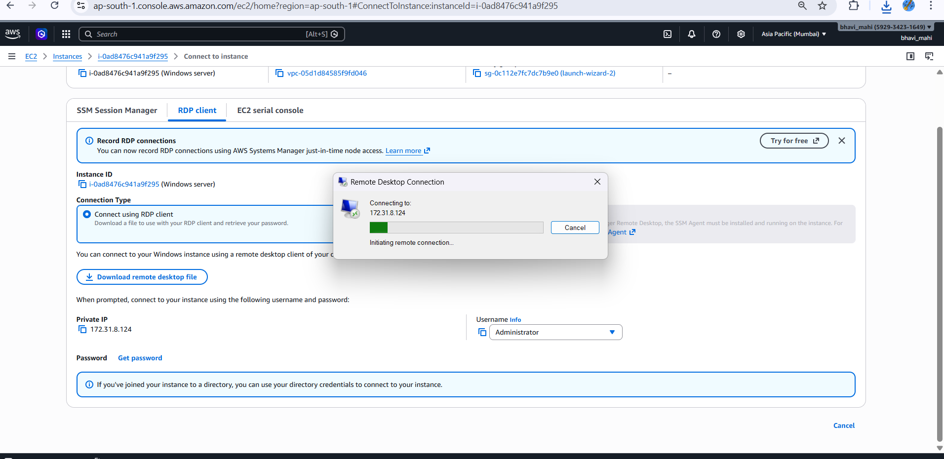

EBS Volume:

